JANUARY NEWS
GRADE TWO

- Language Arts
- Math
- Science

LANGUAGE ARTS

The focus of our writing right now is narratives. Go charts, webs, and cue cards are graphic organizers that are used to organize ideas before story writing. Please see the last page for an example of one of the organizers we are using in class.

We will be using our knowledge of writing descriptive paragraphs and applying it to story writing. Each paragraph is to be about an event that elaborates the story being told.

Each story is to have at least 5 paragraphs:

Introduction:
Introduces
- the setting – where and when
- Main/secondary characters – describe who they are
- Plot/problem – what the story is going to be about

Body:
The body of the story contains at least three events. Each event is a separate paragraph. The events are to tell the story/problem- where the action of the story is.

Conclusion:
Wraps up the story or solves the problem. No new ideas are introduced

The students need to ensure that there is a big idea in the story that is evident (plot/problem) and that the little ideas support the big idea (three events).

We are continuing to work on verbs, nouns, adjectives, and adverbs. The students are working on including these types of words in their stories.

Short and long vowels continue to be reviewed regularly along with their rules. These activities are hands on that involve a combination of group and individual work.

MATH

Measurement is the focus right now. The students are learning about:

- estimate and measure length, height, and distance, using standard units (i.e., centimetre,metre) and non-standard units;
- estimate, measure, and record area, through investigation using a variety of non-standard units (e.g., determine the number of yellow pattern blocks it takes to cover an outlined shape)

Social Studies
We will soon be learning about countries around the world. The students will be learning about different countries – clothing, housing, environment, food, activities, education, and climate. They will be comparing how different countries live to how we live in Canada.

The students will also be learning about the makeup of Canada (that we have provinces and that we live in the Province of Ontario).

SCIENCE

Will be starting the next science unit in March/April. The next unit that will be covered is simple machines

Simple Machines

A machine enables us to use less effort to do work, such as pushing or pulling an object or load.

Lever
A lever is a simple machine for lifting weights or prying something open. Scissors, nutcrackers and tweezers are good levers.

Pulley
A pulley is a simple machine for lifting things. An elevator moves up and down with the help of a pulley system.

Inclined Plane
The inclined plane is a sloping surface which allows an object to be moved from one elevation to another with less effort than lifting. Using an inclined plane requires less work but effort occurs over a greater distance. Pushing or pulling the object using an inclined plane is easier than lifting the object.

Screw
The screw is a simple machine that is like an inclined plane. It is made up of a head, a shaft, and a pointed end. The shaft has a cut going around and around it. This cut is called the thread. The screw fastens things together.

Wedge
A wedge is an inclined plane that moves. It is thin at one end and thicker at the other end. A wedge can lift something or split something apart. Wedges are usually made of wood or metal.

Wheel and Axle
A round type of lever is called a wheel and axle. The wheel turns round a small cylinder called an axle. A wheel and axle can help us lift and move heavy loads.

Please see below for an examples of a web for story writing we are using in the class.

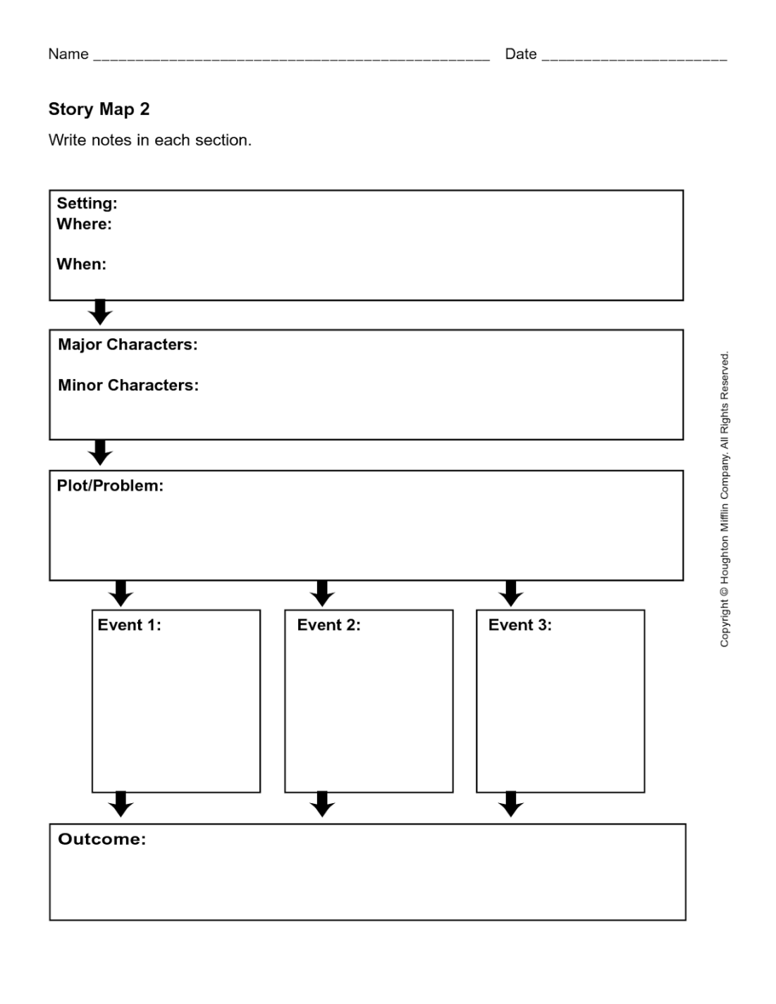

Thank you,
Tammy Harrison-Cecire

