May Newsletter - Grade Two
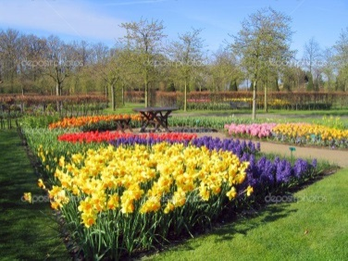

- Language Arts
- Math
- Science
- Social Studies
- Other Business

Language Arts
The topic we continue to focus on is non-fiction writing with a focus on informational reports. The students are learning how to read an informational report and pick out the big ideas. We will also be looking at how to take facts and create an informational report :
The introduction is a general statement about the topic

The body of the report contains two to four paragraphs that tell more about the topic. Each paragraph is to have an introductory sentence with three to four points that support the topic sentence.

The last paragraph is the conclusion. This paragraph wraps up the ideas and does not introduce any new ideas. It usually contains the writer’s opinion of the topic.

We will also be looking at non-fiction texts and the type of textual features that can be found in these books.

Table of contents
Index
Glossary
Photographs
Diagrams
Labels

Math

We are working on time and money.

For time, the students will be learning how to tell and write time to the quarter-hour using the analogue and digital clock. We will be also looking at the passage of time and how to calculate it as well as the relationship between days, weeks, months and years.
For Money the students will be learning to add coins to the value of 100 cents
Science
We are starting wrap up our unit on Simple Machines. The students had fun learning about the six simple machines through hands on centres and videos.

We will soon start learning about animals: what classifies a fish, reptile, amphibian, insect, birds, and mammals; different habitats and enemies; and what the different animals do to survive.

The students will be given an animal to do research on (details will be sent home) and they will be presenting that information in a diorama that will be created in class. An informational report will also be created about a different animal in class.

Other Business
Although spring is here, we are still getting colder temperatures. Please ensure that your child is dressed appropriate for the weather on that day.

Mrs Harrison-Cecire

